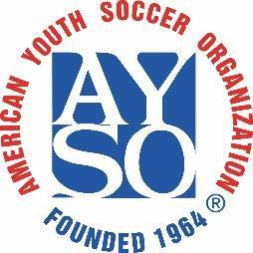 | Sponsored by AYSO Region 16 Torrance, California  2025 Region 16 AYSO All American Turkey Tournament  Team Invitation | 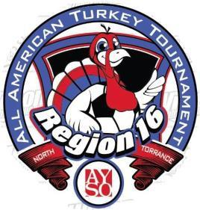
Hello, coaches!
AYSO Region 16 is proud to invite your team to the 2025 Region 16 AYSO All American Turkey Tournament

Scope: | AYSO Invitational – open to AYSO teams only from all Sections.
When: | Friday, Saturday & Sunday, Nov 28th through Nov 30th, 2025 – Rain Dates Jan 10th & 11th, 2026
Where: | The tournament will be held at Columbia Park, Toyota Fields, McGruder Middle school and Lincoln Elementary School, and Torrance, California. There is no charge for parking. No pets are allowed at fields.
Who: | AYSO boys and girl’s teams in age divisions: U-19, U-16 (11v11) 18 players max. U-14 (11v11) 15 players max. U-12 (9v9) 12 players max. and U-10 (7v7) 10 players max. All players must be registered to play in the AYSO 2025 primary season. Guest players will be allowed (3 maximum per team). Co-ed teams will be accepted in boys’ divisions only.
What: | Pool plays tournament. Each team will be guaranteed 3 games in pool play. The top teams will advance to the medal round on Sunday afternoon. All games will be as follows: (60 min. for U-19 & U- 16, 60 min. for U-14, 50 min for U-12, and 40 min for U-10).
Why: | The 2025 Region 16 All American Turkey Tournament is being conducted as a fundraiser by region 16 to raise funds for Field Development, Equipment, & Maintenance, and to provide Scholarship funds for youths in region 16.
Awards: | 2 coaches per team will receive a tournament t-shirt. All players on the 1st, 2nd, 3rd, & 4th place teams will receive a trophy or medal.
Entry Fee, Refunds: | $700 for U-19 & U-16, $650 for U-14, $550 for U-12, $500 for U-10 & U8 $300. A full refund will be issued if the tournament is canceled and cannot be rescheduled. If a team withdraws 30 or more days before the tournament, a full refund is given. Within 30 days of the tournament, no refund is provided unless a replacement team is found.
Referee Fee, Refunds: | $300, refundable within 14 days of the tournament, if referee assignments have been completed. Each team is asked to provide a qualified 3-person referee team to cover 3 games during the tournament. Partial refunds will be given based upon the number of game slots completed.
Rules: | A full set of tournament rules are posted on the tournament website.
Acceptance: | The application deadline is Nov 07, 2025. All teams will be notified within 48 hrs. of the application deadline or receipt of application (whichever is latest) as to their status. Teams that are not accepted will be given the option to have their complete application returned or to be placed on the waiting list.
How: | Team entry applications and all necessary forms are available on the tournament website.  Please send 1 Region check that covers both the Entry and Referee fees, along with the tournament application, referee information form, and team roster to the Tournament Registrar address below. Regional commissioners must sign applications and team roster. The appropriate referee administrator must sign the referee information form. See referee form for details.  Make region check payable to: AYSO Region 16
Address: | Tournament Registrar  2025 Region 16 All American Turkey Tournament 15338 Cranbrook Ave  Lawndale, California, 90260
Information: | Call Paul Lopez (424)645-9683 E-mail turkeytournament@aysoregion16.org  Web site www.ayso16.org

